**EduTutor AI – Project Documentation**

**1.Project Overview**

**EduTutor AI** is an AI-powered educational assistant that helps students learn concepts and generate quizzes dynamically. It uses **IBM Granite LLM** for natural language understanding and **Gradio** for an interactive web interface. The platform supports:

* Concept explanations with examples
* Quiz generation (multiple choice, true/false, short answer)
* Shareable web interface for easy access

**2.Features**

* **Concept Explanation:** Users enter a concept, and the AI generates a detailed explanation.
* **Quiz Generation:** Users enter a topic; AI creates 5+ quiz questions with answers.
* **Interactive UI:** Gradio interface with tabs for explanations and quizzes.
* **AI Powered:** Uses Granite foundation model through Hugging Face Transformers.
* **Cross-Platform:** Can be run on CPU or GPU.

**3.Tech Stack**

* **Frontend & UI:** Gradio
* **AI/ML:** PyTorch, Hugging Face Transformers, IBM Granite LLM
* **Language:** Python 3.10+

**4.Project Structure**

EduTutorAI-Gradio/

┣ app.py # Main Gradio app

┣ requirements.txt # Python dependencies

┣ README.md # Project documentation

┗ models/ # (Optional) Pretrained or fine-tuned models

**5.Installation**

1. Clone the repository:

git clone https://github.com/username/EduTutorAI-Gradio.git

cd EduTutorAI-Gradio

1. Create a virtual environment:

python -m venv venv

source venv/bin/activate # Linux/macOS

venv\Scripts\activate # Windows

1. Install dependencies:

pip install -r requirements.txt

1. Run the app:

python app.py

1. Open the Gradio interface (the terminal will provide a local URL or a shareable link).

**6.Usage**

* **Concept Explanation:** Enter a topic (e.g., "Machine Learning") → Click “Explain” → Get AI-generated explanation.
* **Quiz Generation:** Enter a topic → Click “Generate Quiz” → Get 5+ questions with answers.

**7.Future Improvements**

* Integrate with **React frontend** for a full LMS-style platform.
* Connect to a **backend database** to store quizzes and track progress.
* Add **Google Classroom or LMS integration**.
* Implement **adaptive difficulty** based on student performance.

**8.Dependencies**

* Python 3.10+
* Gradio
* PyTorch
* Transformers
* IBM Granite LLM

# Screenshots :

1.Getting IBM Granite model from Hugging Face

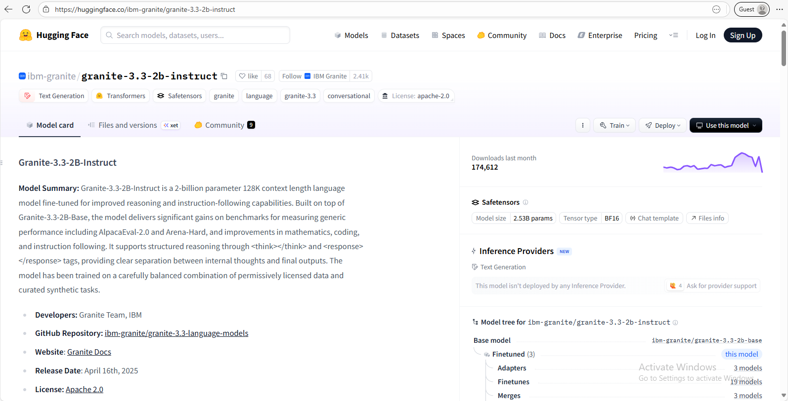

2.Coding in Google Colab

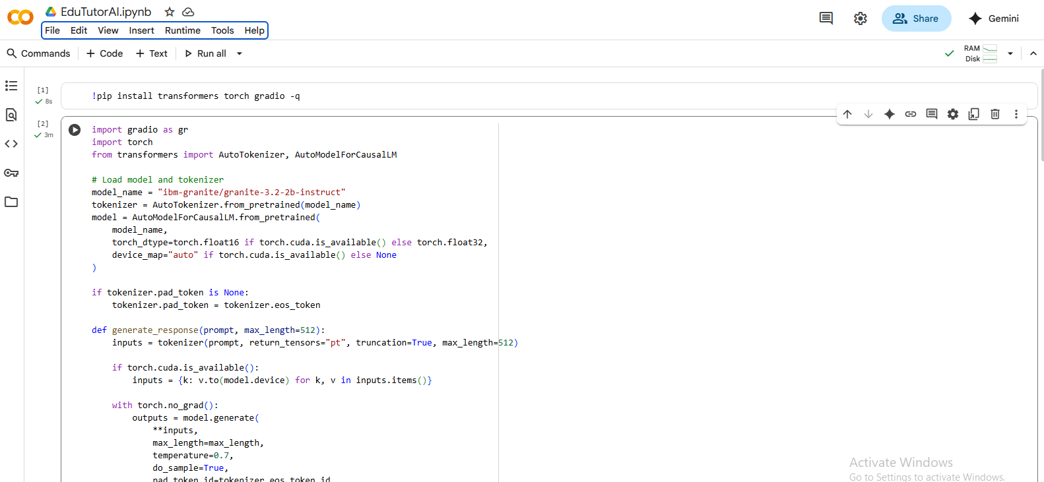

3.Running the code

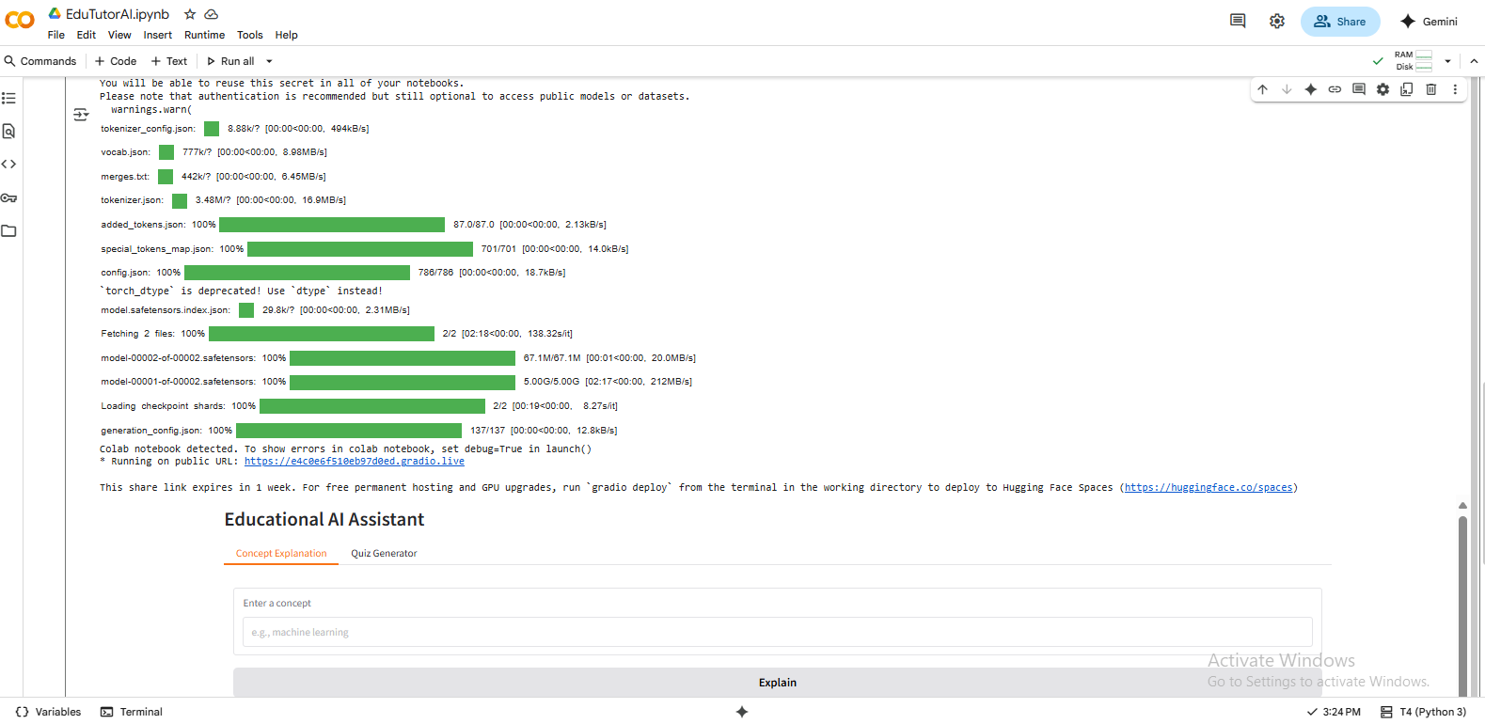

4.Testing the Public URL

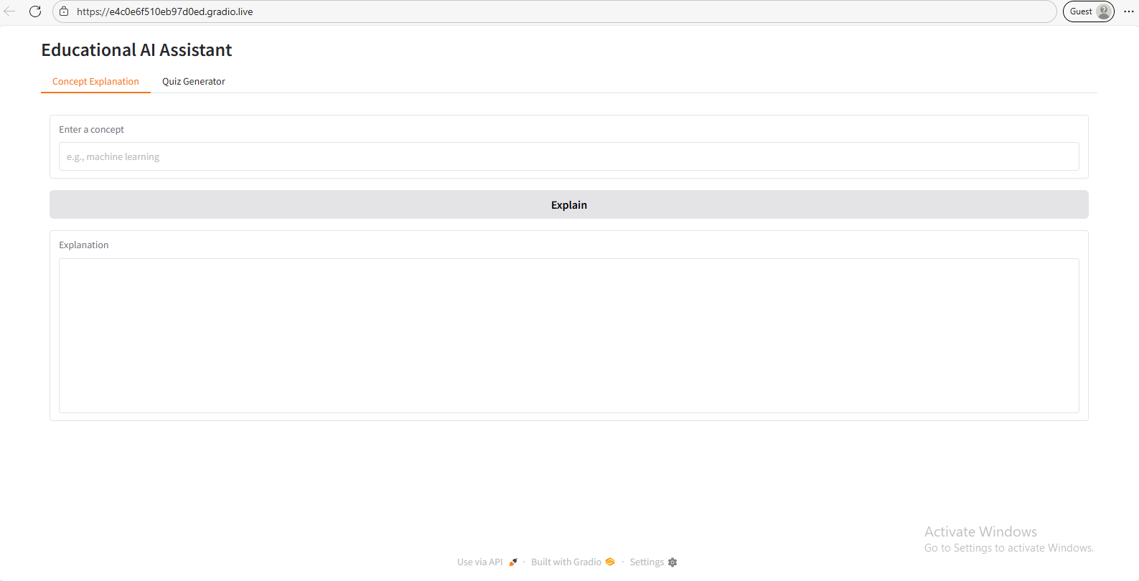

5.Testing concept explanation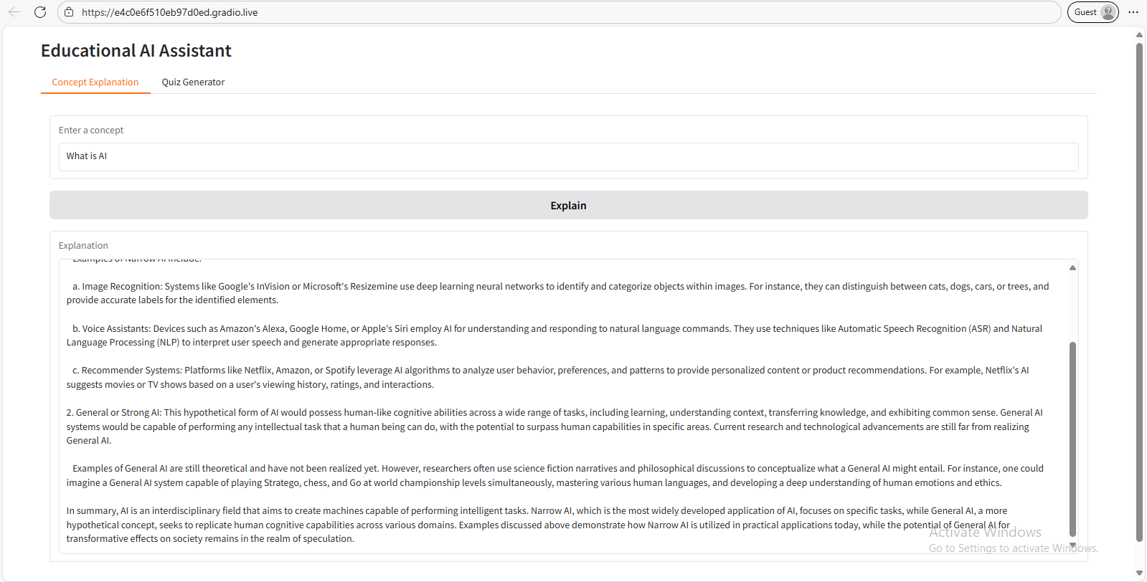

6.Testing quiz generation

